**Crontab Entries**

1. April 5th Midnight
2. 5th of Every November, January, June **if it is a Thursday**
3. At **05 and 27th minutes** of **9, 10, 11** hours every day
4. **34 minutes** of **9th hour** on **15th August**
5. Every midnight
6. Every Weekend (**Saturday night 11:59 PM**)
7. After every reboot

| **Task Description** | **Crontab Entry** |
| --- | --- |
| April 5th at Midnight | 0 0 5 4 * your_command_here |
| 5th of Jan, Jun, Nov if Thursday | 0 0 5 1,6,11 4 your_command_here |
| At 05 & 27 minutes of 9,10,11 AM | 5,27 9-11 * * * your_command_here |
| 15th August at 9:34 AM | 34 9 15 8 * your_command_here |
| Every Midnight | 0 0 * * * your_command_here |
| Saturday 11:59 PM | 59 23 * * 6 your_command_here |
| After Reboot | @reboot your_command_here |

1.April 5th Midnight

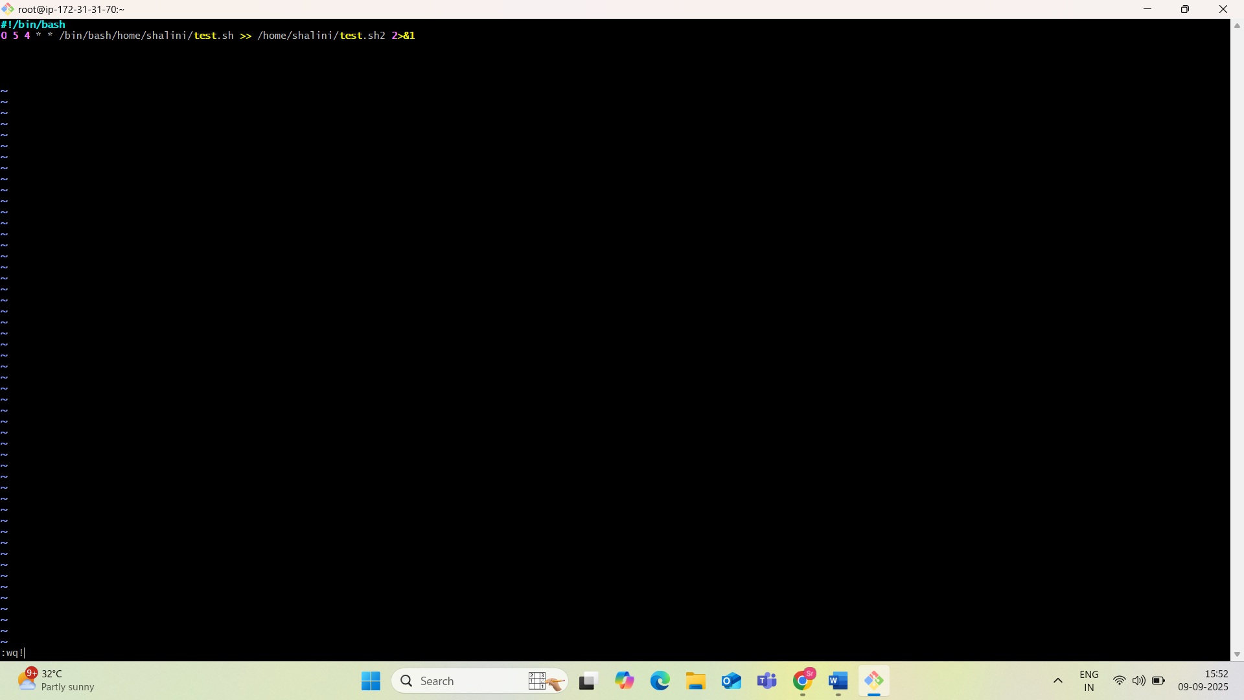

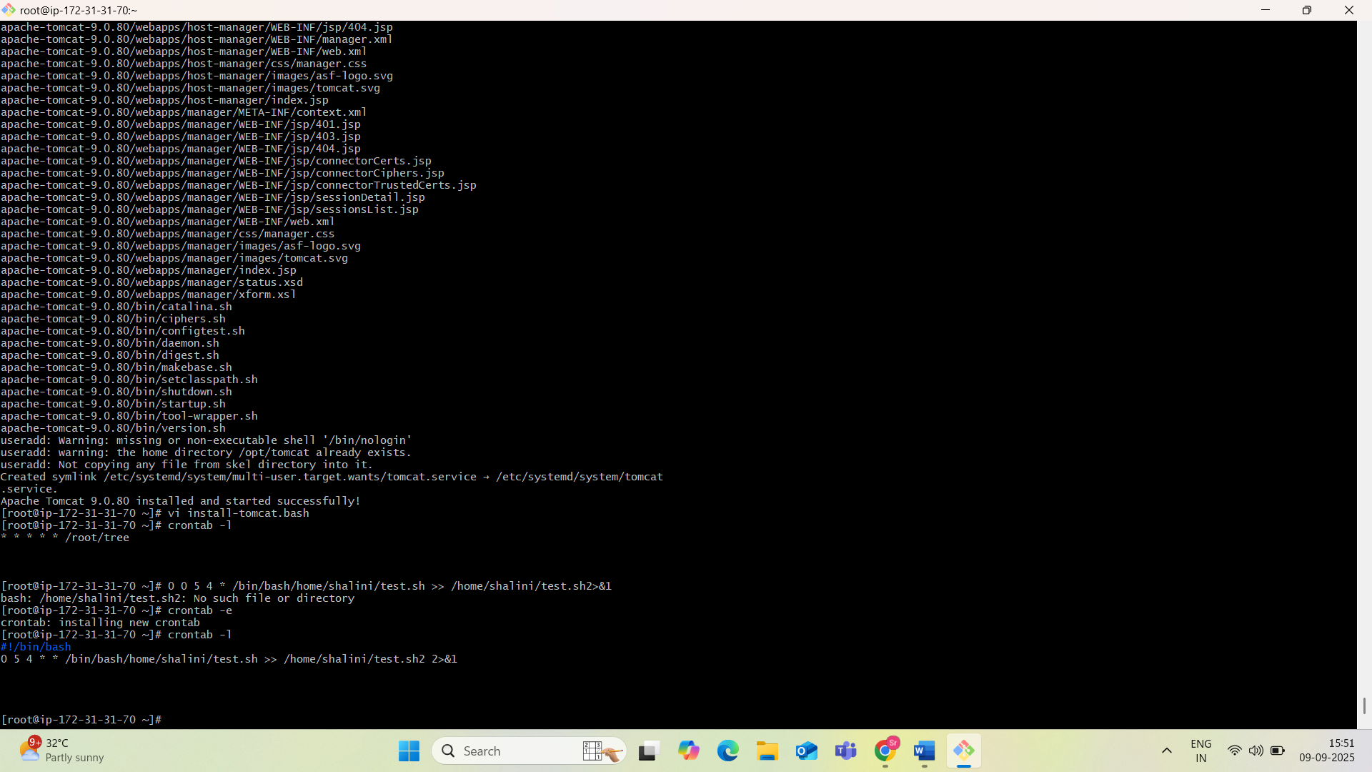

**5th of Every November, January, June — only if it is a Thursday**

0 0 5 1,6,11 4 your_command_here

**Explanation:**

* 0 0: Midnight
* 5: 5th day
* 1,6,11: January, June, November
* 4: Day of week (Thursday: 0=Sunday, 6=Saturday)
* Runs **only if 5th falls on a Thursday**

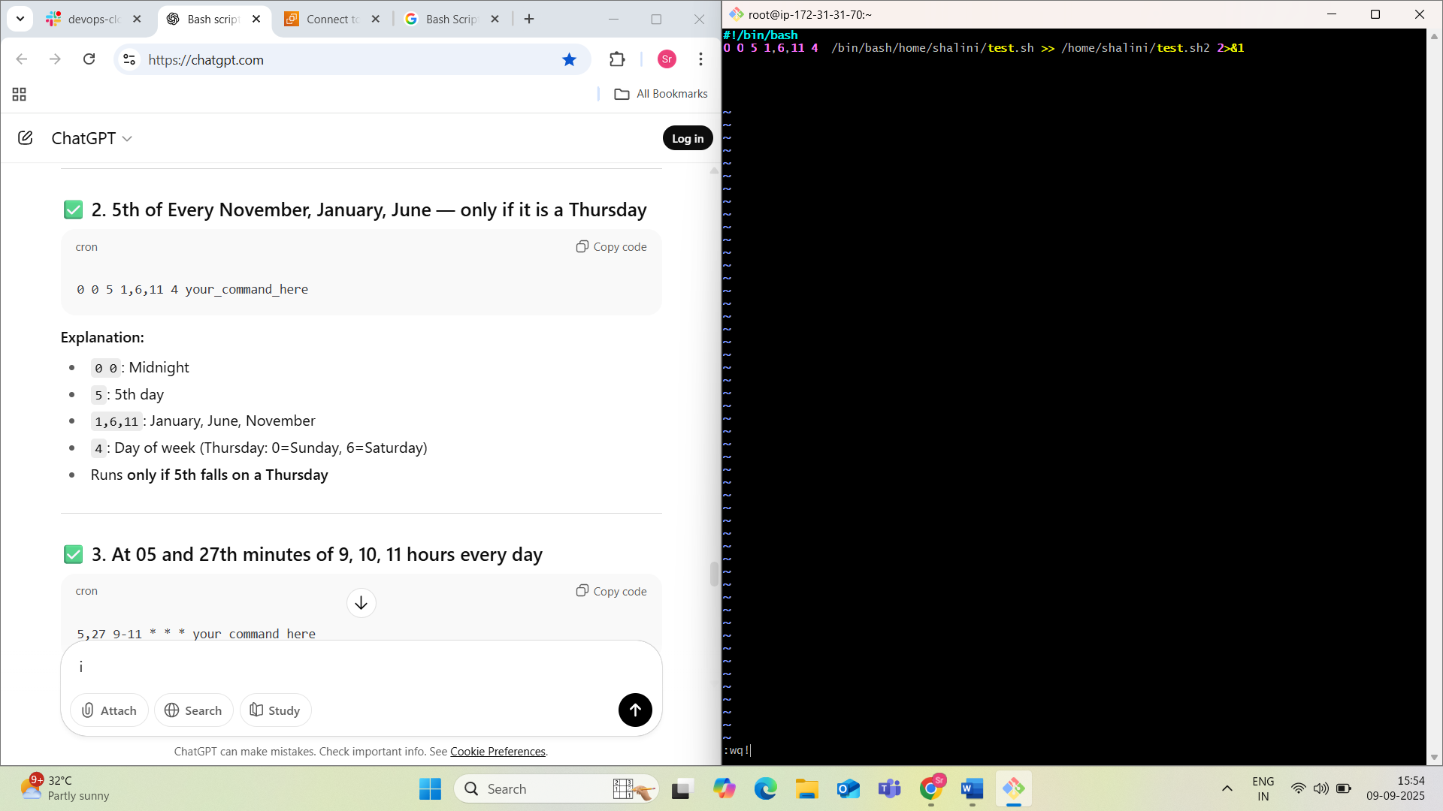

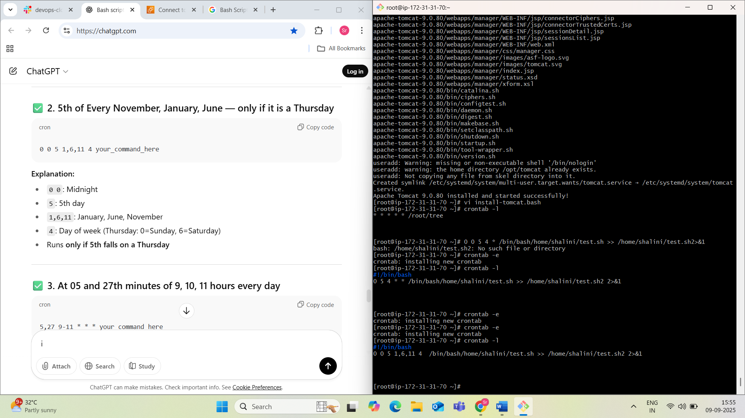

**3. At 05 and 27th minutes of 9, 10, 11 hours every day**

5,27 9-11 * * * your_command_here

**Explanation:**

* 5,27: Minute 5 and 27
* 9-11: Hours 9, 10, 11
* * * *: Every day, every month, any day of week

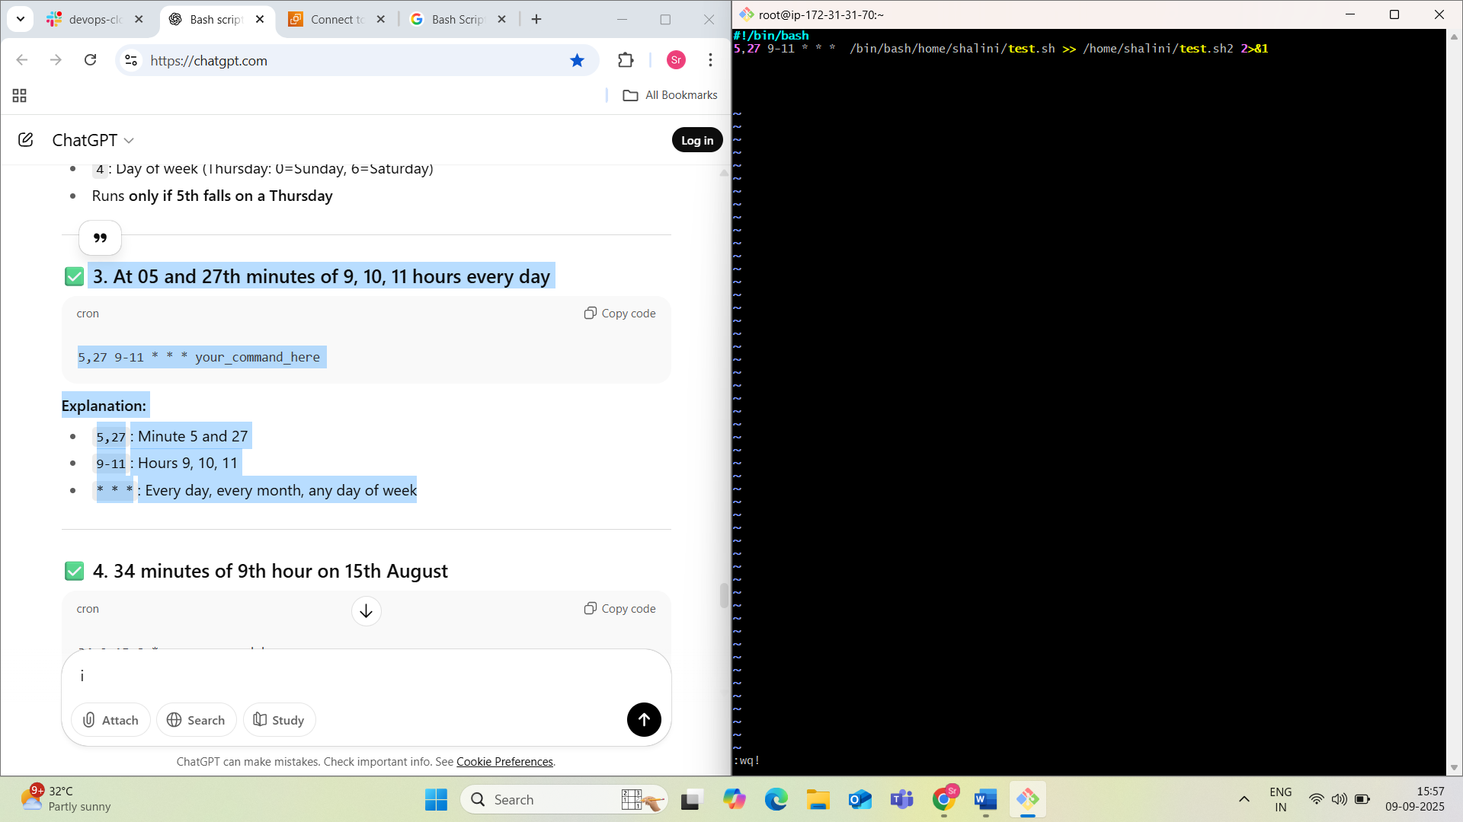

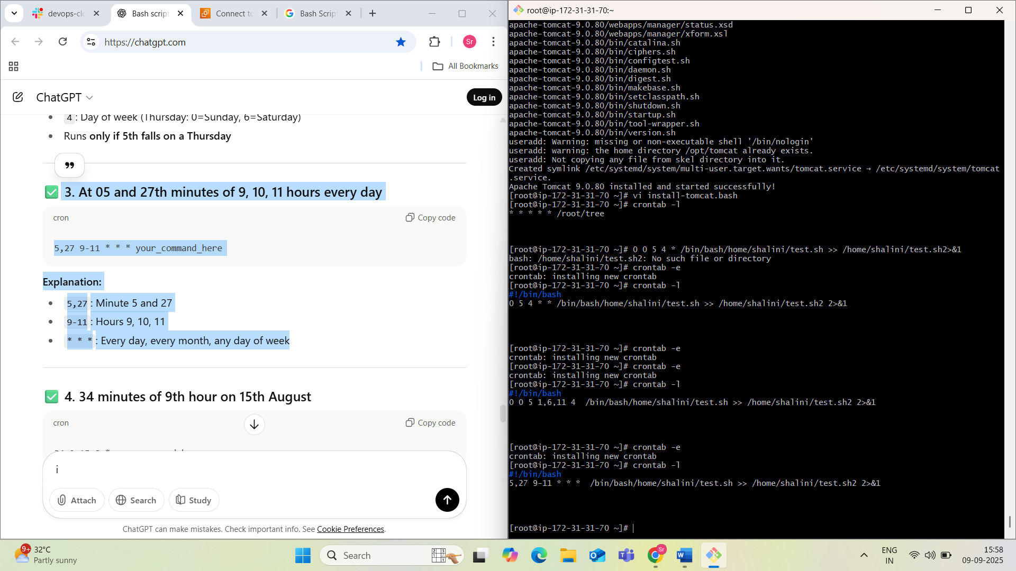

**4. 34 minutes of 9th hour on 15th August**

34 9 15 8 * your_command_here

**Explanation:**

* 34 9: 9:34 AM
* 15: 15th day
* 8: August
* *: Any day of the week

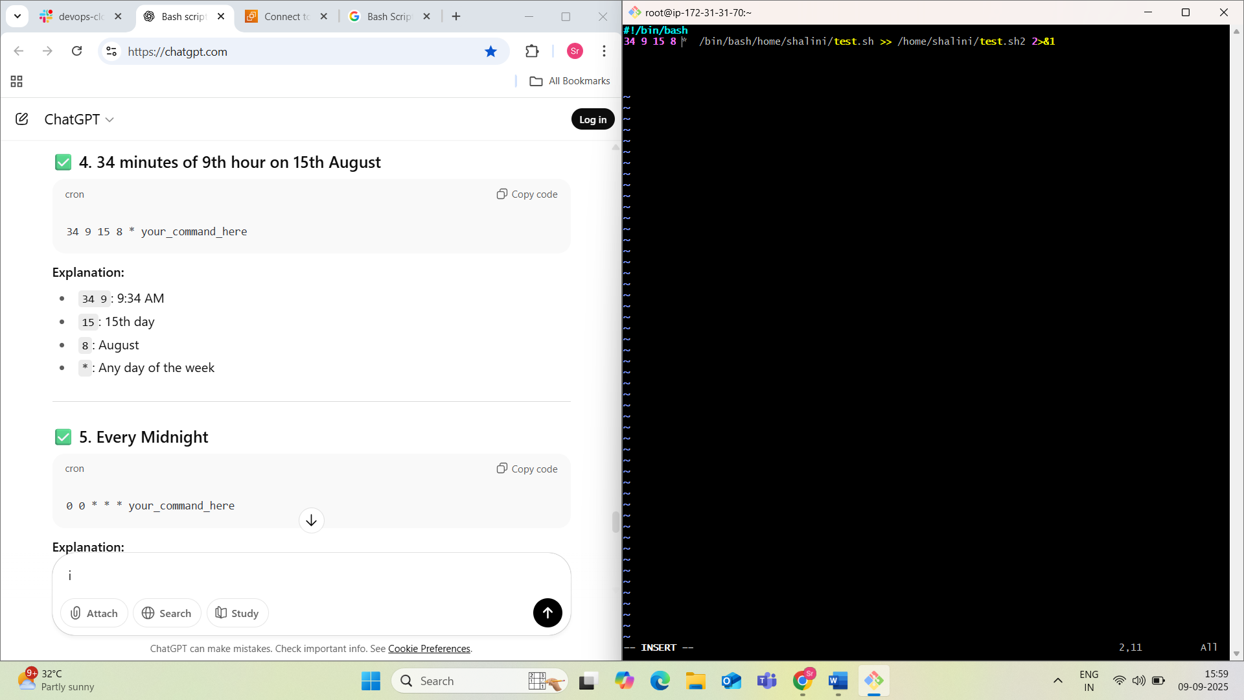

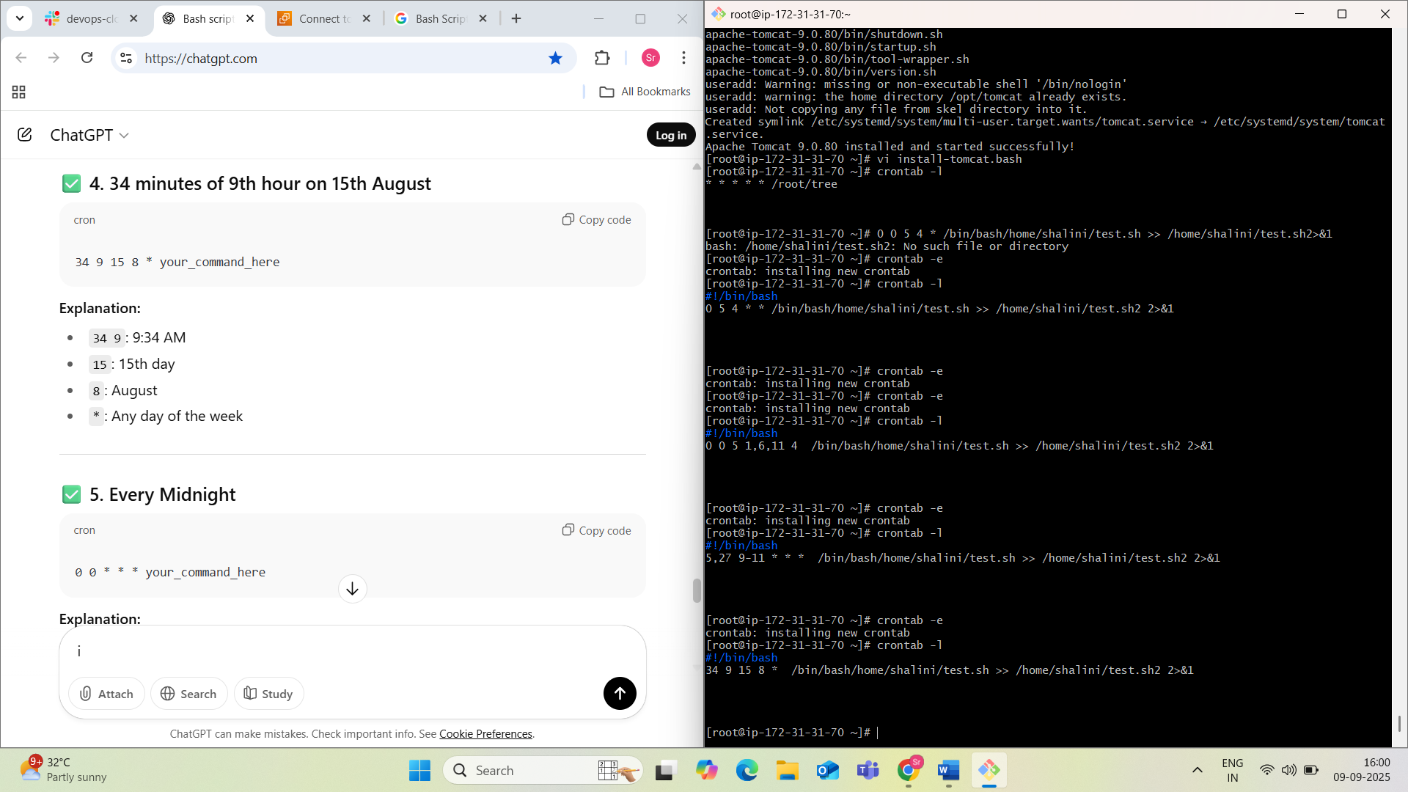

**5. Every Midnight**

0 0 * * * your_command_here

**Explanation:**

* Runs at 00:00 (midnight) every day

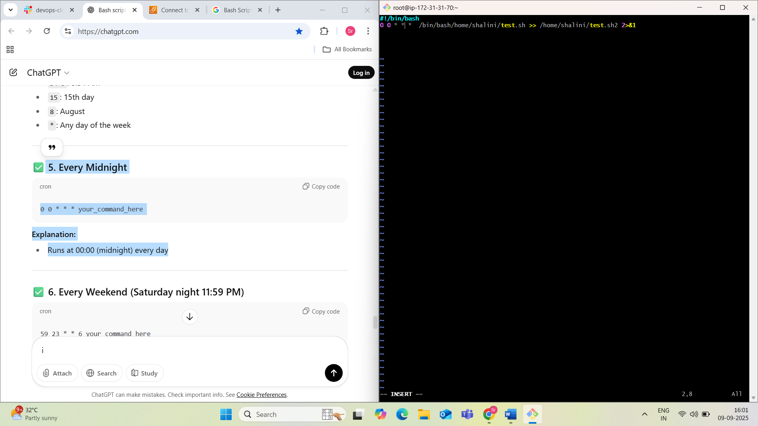

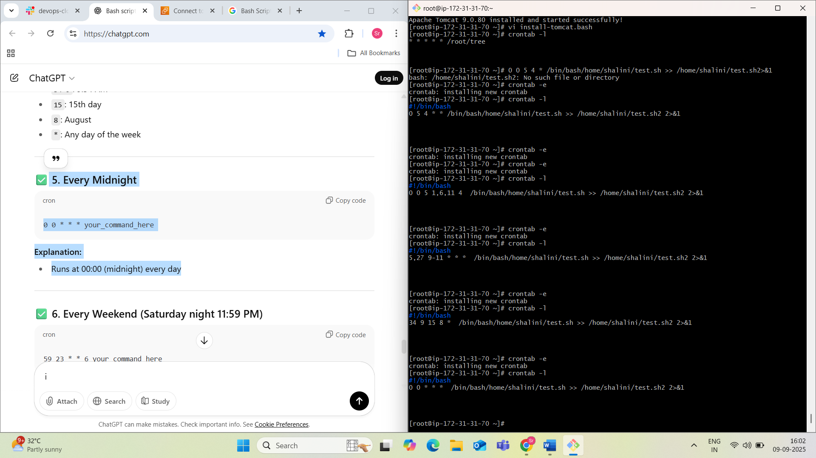

**6. Every Weekend (Saturday night 11:59 PM)**

59 23 * * 6 your_command_here

**Explanation:**

* 59 23: 11:59 PM
* 6: Saturday

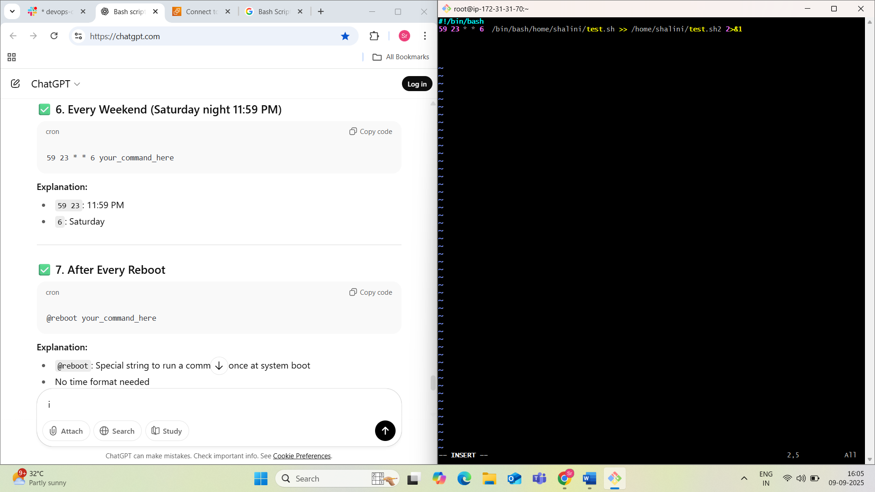

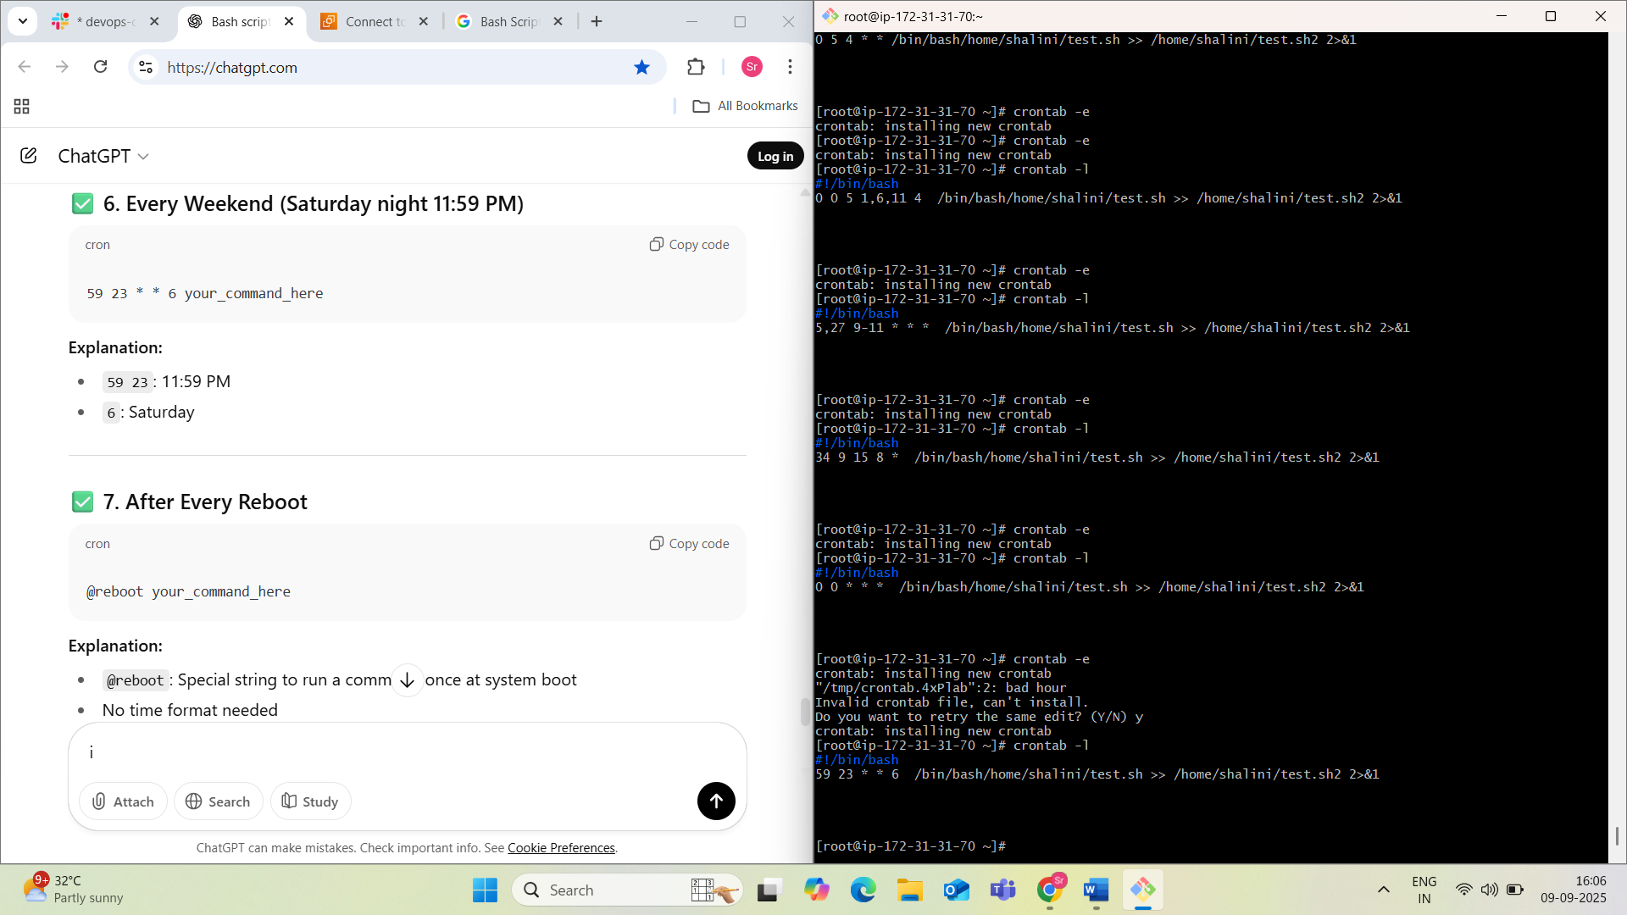

**7. After Every Reboot**

@reboot your_command_here

**Explanation:**

* @reboot: Special string to run a command once at system boot
* No time format needed

